
Welcome to the team!
We are thrilled to have you start getting trained and ready to connect with schools, students, families, and health care providers – we know you’re going to be a valuable asset to our team and can’t wait to see how you make this role your own.
If after reviewing this packet you have questions, please reach out to Rachel (email listed on page 3). There is a lot of information and instructions please read it thoroughly! This packet and the trainings listed are meant to get you started so that you are ready to tackle visits and interacting with the school communities in August.

THANK YOU!

Orientation to Program Names and Abbreviations
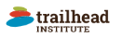

ACCORDS (Adult and Children’s Center for Outcomes Research and Delivery Science) is the Center at Anschutz Medical Campus (University of Colorado and Children’s Hospital) that received the grant for this project. Many of you are contracted through ACCORDS.
Trailhead Institute is a community public health partner working on this project. Kris is contracted through Trailhead Institute.

Better Asthma Control for Kids (BACK) is the name of our school-based asthma program. Our school nurse partners were first introduced to the program as Stop Asthma Attacks and might know us through this name as well.

DECIPHeR: This is the name of the grant that is funding our project through the National Heart, Lung and Blood institute (NHLBI) at the National Institutes of Health (NIH). DECIPHeR stands for Disparities Elimination through Coordinated Interventions to Prevent and Control Heart and Lung Disease Risk

Meet the Team
Leads:

Lisa Cicutto RN, ACNP(CERT), PhD lisa.cicutto@cuanschutz.edu
Melanie Gleason PA, MS melanie.gleason@childrenscolorado.org
Key Contacts:
Rachel Armstrong Rachel.kate.armstrong@cuanschutz.edu
Holly Coleman hcoleman@trailhead.institue
Misha Brtnikova PhD, MPH MICHAELA.BRTNIKOVA@CUANSCHUTZ.EDU

Setting up your University of Colorado email
You should already have access to your email and hopefully have received your laptop in the mail. If not, please get in touch with Rachel.
You can gain access to your account by resetting your password here: Password Reset | University of Colorado Denver (ucdenver.edu). You are required to change your password for security purposes about once a year so please use the same link to do that. If you have issues, contact the Office of Information Technology at 303-724-4357 or visit them online at Office of Information Technology (ucdenver.edu). Having a CU email affords you access to our online trainings and a Zoom profile.
POI Number: A POI number works as an employee ID for independent contractors

Setting up your email signature
We want to appear as a united team and easily recognizable by our school nurses and other partners. One way to do this is to use the same signature format in Outlook.
- Navigate to Settings – Mail - Compose and reply
- Select New signature
- Title your signature
- Insert your signature from the format below – the pronouns are optional but encouraged
--
Your Name
Asthma Navigator
Contracted by Better Asthma Control for Kids (BACK)
Insert Region (Lower Arkansas Valley; Greeley/Morgan/Weld; Pikes Peak; Mesa/Delta/Montrose)
E: xxx@cuanschutz.edu P: xxx.xxx.xxxx
(Pronouns: she, her, hers)


- Set as your default signature for new messages and replies/forwards

Zoom access (IT training materials)
Once you have an CU email and POI, you will also have access to a paid Zoom account. You can sign in here: Video Conferencing, Web Conferencing, Online Meetings, Screen Sharing - Zoom with your CU sign in credentials.
Zoom Etiquette as a Participant
Our first meeting together and all of our check-in’s will be over Zoom. In case you are not already familiar with how to be a productive participant in a zoom meeting, please see the guidelines below!
- Find a quiet place if possible
- Mute yourself when you’re not talking
- If you’re comfortable and able, please leave your video on
- Use the raise hand feature to interject with a question or thought
  - This is in the reactions section at the bottom of your screen
  - Please click it again to lower your hand once you’ve shared!
- OR simply use the chat box
- Feel free to use the reaction emojis to react without unmuting
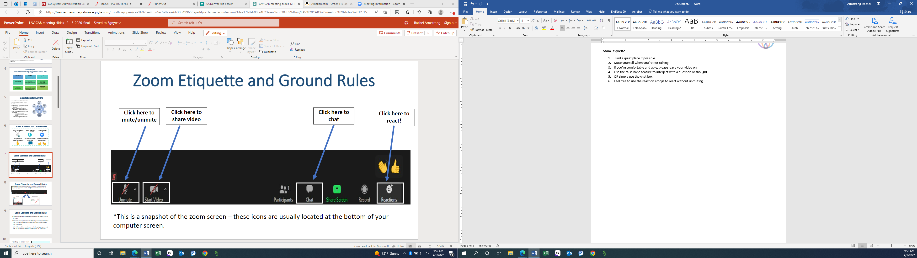

Zoom Etiquette as an Organizer
You may need to set up Zoom meetings with families, school nurse partners, or other key players. Below are some instructions on how to set up a professional Zoom meeting. If you feel you need more training or practice in this area, please reach out to Rachel who can provide you with more structured Zoom training options.
- Set up a meeting through your University of Colorado account: Video Conferencing, Web Conferencing, Online Meetings, Screen Sharing - Zoom
  - Navigate to “Meetings”
  - Click “Schedule a Meeting”
  - Select the date, time, and length
  - Click “Save”
- Instead of sending out an invite through Zoom, it is best to send it through Outlook calendar
  - Create a calendar invite in Outlook – add the day, time, and participants
  - Click “Copy Invitation” in Zoom and paste it in the description of your Outlook Invite
  - Include the Zoom link as the meeting location

Invoicing and Your Timesheet
You will need to complete an invoice every month (or twice a month if you prefer). We need you to carefully track your hours for the research team to complete a cost assessment – not to micromanage you! Please find the template for your invoice and an example in our shared google drive. You will submit your timesheet to Rachel and Misha (emails above) once a month who will approve it and forward to Trailhead who takes care of the payment process. Please include the invoice number and your initials in the invoices you send.

