BACK Fax Line: (833) 493-3635; 1 user, 500 pages/month limit
Account Number: ACCT-807398
Account holder name: Anowara Begum

To access the Fax line account, go to https://home.westfax.com/
Provide:
- Username: back@cuanschutz.edu; Password: DECIPHeRDenver2024

For any technical issues: please call 303-299-9329 or email at info@westfax.com; refer to the account number and the account holder name above if prompted.

To Send a Fax:
- Log into the web portal > (westfax.com/print-to-fax)> provide username and password listed above
- Click on the SEND FAX option located on the upper left side of the screen
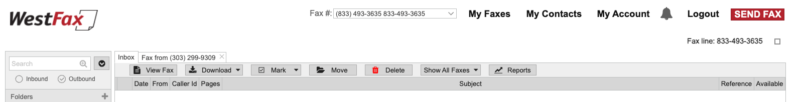
- Next, a pop-up screen will appear > complete the required information
  - Add clinic/school fax number > you can also save them as contact for future
  - Add a header: BACK project HCP Letter
  - Subject: SG Asthma Visit Summary Letter V1_Date
  - Leave the reference field blank
  - Attached the letters/documents by clicking on the ‘Browse for Documents’ > double check if you have attached the correct file
- Review your information and click on ‘Send Fax’
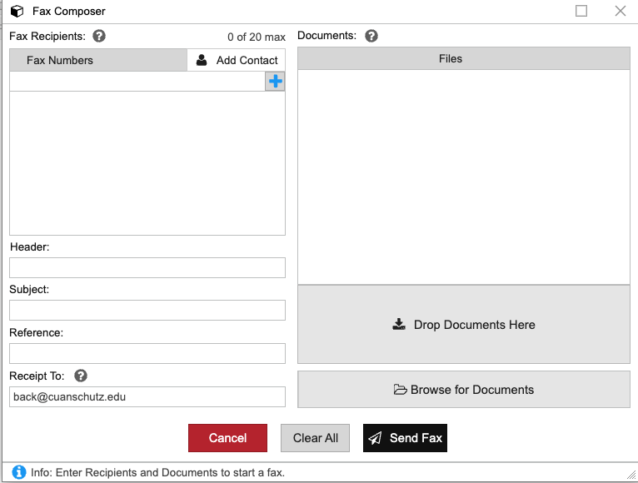

To Receive a fax:
- Provide the BACK Fax line number, (833) 493-3635, to sender.
- Use our web portal (home.westfax.com) and check your inbound faxes.
- Download the document by clicking on the ‘Download’ button as shown below.
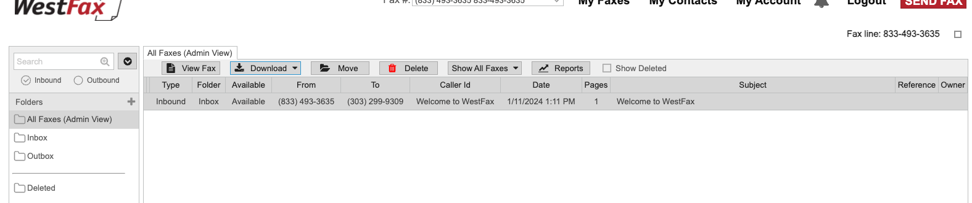
- Save the file in your designated 'AN Personal folders' on Egnyte

Here are a few key points to keep in mind:
- We will be sharing one FAX account, so it's possible that you may see inbound and outbound FAX from other navigators. To respect the privacy of the other students, do not open a FAX that you don't recognize.
- The page limit for our FAX account is 500 pages per month, so please let us know if you need to send more pages, and we can pay an additional fee for those.
- Please note that you are responsible for checking the inbox and outbox of the Fax account after sending out letters to the clinics - make a plan to log in and check the inbox regularly to ensure that we don't miss any inquiries from the clinic side.
- If you receive any documents from the clinic, save them in your designated 'AN Personal folders' on Egnyte. Do not save any student information on your personal computer. This goes for all documents/letters that include student information.

HAPPY FAXING!

