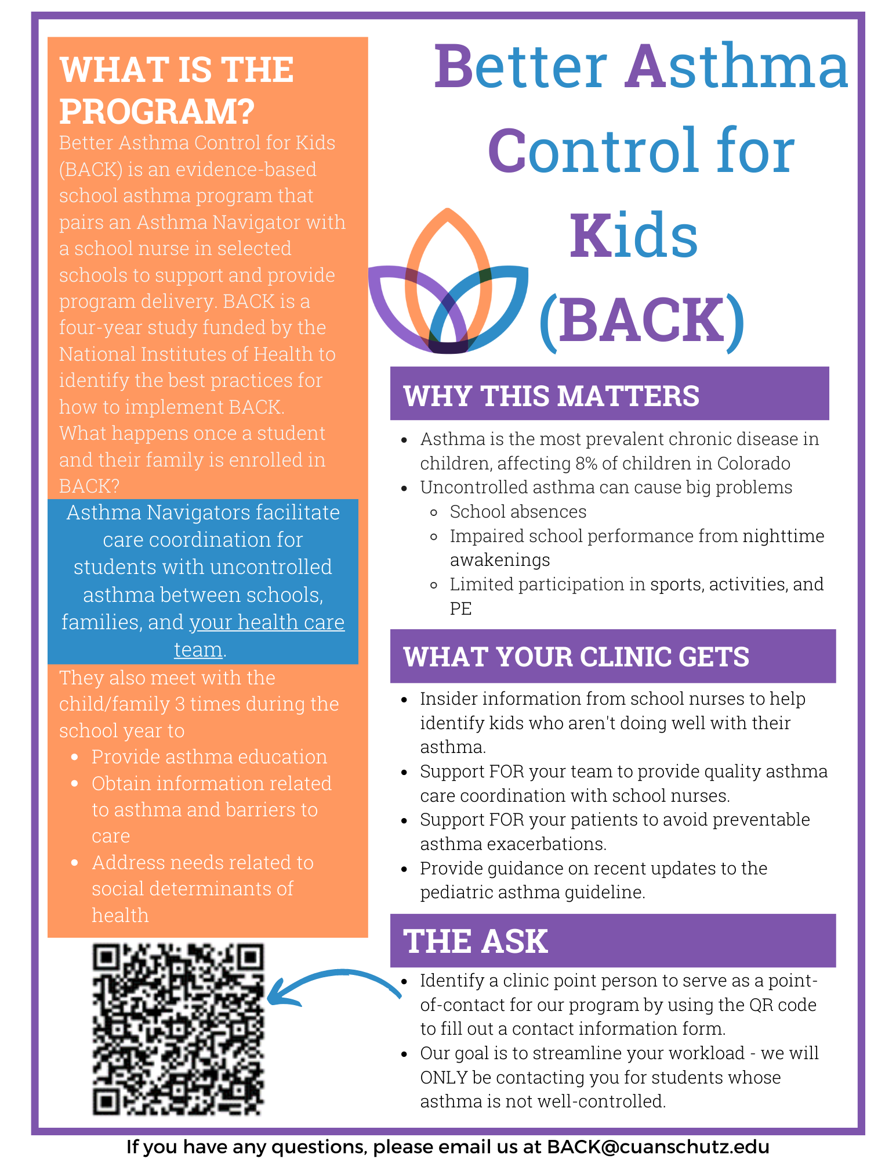
Table of Contents
Plan for Partnering Letter for Healtcare Providers 3
Visit 1 Letter Template from Navigator to Healthcare Provider 4
5
Letter Template to Healthcare Provider if Asthma Care Items Are Missing 6
Visit 3/End of The Year Letter Template from Navigator to Healthcare Provider 7
Letter Template for Poorly Controlled Asthma 9

Plan for Partnering Letter for Healtcare Providers
Please join us to help improve asthma care for kids in Colorado!
Dear Health Care Provider,
We are excited to share with you information about a new school-based asthma program being implemented in schools in your community called “Better Asthma Control for Kids (BACK)”.
Key points – our BACK program is an effective school-based asthma intervention to support kids who have poorly controlled asthma. BACK has been shown to improve asthma outcomes through care coordination between clinics, families and schools.
- BACK is launching in Colorado Springs, Greeley/Fort Morgan and the Lower Arkansas Valley in Fall 2023 – a student from your clinic may be enrolled through their school if they have markers of poor asthma control, such as frequent need for steroid bursts or frequent urgent care/ED visits.
- Our goal is to make your workload lighter. We will reach out twice yearly with updates on your patients in BACK to share key data to inform your clinical care. See below for details.
  - Please sign up here or below to designate a clinic staff member as point of contact for your clinic if one of your patients in enrolled in BACK.
How does my clinic interact with BACK?
We respect how busy your practice is and do not want to add any additional burden to you or your staff. We will notify your clinic point of contact in the following instances:
- If any of your patients enroll in BACK, we will provide you with twice-yearly clinical summaries that include:
  - Summary of current asthma care issues, such as any problems with inhaler technique/adherence and environmental triggers.
  - Need for forms or prescriptions to facilitate asthma medication access at school.
  - Results of screening for needs related to social determinants of health, and how these needs were addressed
- If there are any requests from you as the healthcare provider, such as asthma medications needed on-site at school, we will include those requests with check-boxes to highlight the needs “at-a-glance”.

Don’t forget to click here to fill out a form to identify a staff member as a point-of-contact for your clinic (Name, Phone #, Fax#, and e-mail), so our team can share key data to inform clinical care on your clinic’s patients who enroll in BACK.
If you have questions or needs, please reach out to us at BACK@cuanschutz.edu or your local asthma navigator, AN name and email.
For more asthma related resources, visit our website’s school nurse resource page www.Coloradokidswithasthma.org or scan the QR code below.
We are looking forward to working with you to support youth with asthma and their families for a successful school journey.

Sincerely,
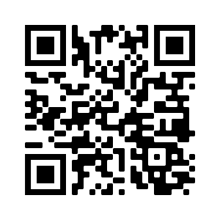
Stanley Szefler, MD
Lisa Cicutto, RN, ACNP (cert), PhD
Amy Huebschmann, MD, MSCS

Enclosures: sample templated letters to be faxed to clinic champion from school nurse-led team member or Asthma Navigator

Visit 1 Letter Template from Navigator to Healthcare Provider

Child Name: ___________________________
DOB: _________________________________
Caregiver Name: ________________________
Caregiver Telephone #: ___________________
Date: _________________________________

Dear Health Care Provider,
Your patient is participating in the Better Asthma Control for Kids (BACK), a school-based asthma education and care program that is being offered at some schools in [DISTRICT]. You have been identified as the child’s asthma care provider.

If this patient is no longer under your care, please check the box and fax (ADD FAX # HERE) this form back to us:
o Patient no longer seen in this clinic.
Asthma information: Based on the most recent encounter we had with your patient, the following asthma information was obtained.
What we are asking you to do – please send us these necessary items for asthma care that are missing:
- No action required at this moment
- Fax an up-to-date Colorado Asthma Care Plan and Medication Order for School and Child Care settings (copy included for your convenience) Could we add the form here by hyperlink?
- Prescribe an extra quick relief inhaler for use at school
- Prescribe an extra quick relief inhaler for use at home
- Prescribe a “spacer” (valved-holding chamber) to have for use at school We are supplying a spacer for school dos we need this on here?
- Prescribe a “spacer” (valved-holding chamber) to have for use at home
- Other: ______________________________________________________________________________
- Please reply to this message (link) if you have any questions or concerns about (child’s name) participation in the program or if you have special request regarding their asthma management at school.
Date of encounter: __________________ Asthma Control based on Asthma guidelines Controlled Uncontrolled
Days missed from school due to asthma this year: _______________________________________________________
Exacerbations requiring medical attention or oral steroids in past XX months: _________________________________
Long-term control medications, dosage, frequency: ______________________________________________________
Quick relief medications, dosage, frequency: ___________________________________________________________
Taking current asthma medication as directed Yes No
Comments: ______________________________________________________________________________________
We have asked the caregiver to schedule an appointment with your office to review asthma control Yes No

Social Determinants of Health: At the recent encounter with your patient, potential barriers to access health such as affordability of medications, food insecurity, transportation, and health literacy were assessed.
- FYI only -- No unmet social needs identified – no actions requested of health care team
- Unmet social needs identified as shown below, but our Asthma Navigator is working with caregivers to access resources – no actions requested of health care team at this time
- ACTION REQUESTED - Request your clinic care manager contact us regarding these unmet social needs that our asthma navigator has not been able to address to date:

Communication from provider to school health team: (please check as many responses that apply and fax form to our office)
- Thank you for update, will have clinic staff contact family and schedule appointment.
- Patient seen and medications changed. See updated asthma treatment plan attached
- School plan completed and faxed to school.
- Would like more information, please contact our office at: _________________________________
- Other comments: __________________________________________________________________

If you have questions about this program, please contact me.

Health Care Practice

Health Care Provider Name

Fax

Sincerely,
School:
E-mail:
Phone:
Fax:
Cc caregiver:

For more information about asthma, please visit ColoradoKidsWithAsthma.org OR scan the QR code

Letter Template to Healthcare Provider if Asthma Care Items Are Missing

Child Name: ___________________________
DOB: ________________________________
Caregiver Name: _______________________
Caregiver Telephone #: __________________
Date: ________________________________

Dear Health Care Provider,
You have been identified as the child’s asthma care provider.
If this patient is no longer under your care, please check the box and fax (ADD FAX # HERE) this form back to us:
o Patient no longer seen in this clinic.

What we are asking you to do - please send us the following item(s) that are needed for asthma care:
- Colorado Asthma Care Plan – enclosed, please fax back to our school
- Quick relief inhaler for school
- Quick relief inhaler for home
- Prescribe a “spacer” (valved-holding chamber) to have for use at school
- Prescribe a “spacer” (valved-holding chamber) to have for use at home
- Other:

If you have questions about this program, please contact me.

Health Care Practice

Health Care Provider Name

Fax

Sincerely,
School:
Contact:
Email:
Phone:
Fax:
CC parent:
For more information about asthma, please visit ColoradoKidsWithAsthma.org OR scan the QR code

Visit 3/End of The Year Letter Template from Navigator to Healthcare Provider

Child Name: ___________________________
DOB: ________________________________
Caregiver Name: _______________________
Caregiver Telephone #: __________________
Date: ________________________________

Dear Health Care Provider,
Your patient completed their participation for the school year in the Better Asthma Control for Kids (BACK), a school-based asthma education and care program that is being offered at some schools in [DISTRICT].

If this patient is no longer under your care, please check the box and fax (ADD FAX # HERE) this form back to us:
Patient no longer seen in this clinic.

End of the school year summary: Based upon the most recent encounter we had with your patient, the following asthma information was obtained.
Date of encounter: __________________ Asthma Control based on Asthma guidelines Controlled Uncontrolled
Days missed from school due to asthma this year: _______________________________________________________
Exacerbations requiring medical attention or oral steroids in past XX months: _________________________________
Long-term control medications, dosage, frequency: ______________________________________________________
Quick relief medications, dosage, frequency: ___________________________________________________________
Taking current asthma medication as directed Yes No
Comments: ______________________________________________________________________________________
We have asked the caregiver to schedule an appointment with your office to review asthma control Yes No

Asthma self-management skills assessed:
- Adherence with controller medication:
- Number of missed days controller medication in the last 2 weeks:
- Inhaler technique assessment (score of 5 = proficient):

Social Determinants of Health: At the recent encounter with your patient, potential barriers to access to health such as affordability of medications, food insecurity, transportation, and health literacy were assessed.
- FYI only -- No unmet social needs identified – no actions requested of health care team
- Unmet social needs identified as shown below, but our Asthma Navigator is working with caregivers to access resources – no actions requested of health care team at this time
- ACTION REQUESTED - Request your clinic care manager contact us regarding these unmet social needs that our asthma navigator has not been able to address to date:

Checklist/reminder tips for next school year: To help prepare your patient for managing their asthma for next school year, please be sure to provide them with the following.

- Colorado Asthma Care Plan – enclosed, please fax back to our school
- Quick relief inhaler for school
- Quick relief inhaler for home
- Spacer for school
- Valved-holding chamber to have for use at school
- No action required at this moment
- Other: __________________________________________________________________________________________________________________________________________________________________________

If you have questions about this program please contact me.

Sincerely,

Health Care Practice

Health Care Provider Name

Fax
School:
E-mail:
Phone:
Fax:

Cc caregiver
For more information about asthma, please visit ColoradoKidsWithAsthma.org OR scan the QR code

Letter Template for Poorly Controlled Asthma

Child Name: ___________________________
DOB: ________________________________
Caregiver Name: _______________________
Caregiver Telephone #: __________________
Date: ________________________________

Dear Health Care Provider,
Your patient is participating in the Better Asthma Control for Kids (BACK), a school-based asthma education and care program that is being offered at some schools in [DISTRICT]. You have been identified as the child’s asthma care provider.

If this patient is no longer under your care, please check the box and fax (ADD FAX # HERE) this form back to us:
o Patient no longer seen in this clinic.

We wanted to communicate with you regarding your patient asthma control based our encounter at the latest BACK asthma visit. The patient’s asthma is not well controlled based on our assessment. The patient:
- # of days had asthma symptoms, cough, wheeze, or shortness of breath over the last 4 weeks
- # of days had nighttime awakening due to asthma over the last 4 weeks
- # of days used rescue medication (albuterol) use for symptom control over the last 4 weeks

We checked the adherence and techniques with medications and encouraged them to follow the asthma plan that you developed. We also recommended that family contact your office to schedule a follow up visit with you for further steps.

Please let us know (ADD NAVIGATOR’S CONTACT INFORMATION) if your office followed up with this patient regarding their asthma. If they completed a visit please advise of any changes to their asthma management by faxing a new Asthma Action Plan and/or the visit note.
If you have questions about this program, please contact me.

Health Care Practice

Health Care Provider Name

Fax

Sincerely,
School:
E-mail:
Phone:
Fax:
For more information about asthma, please visit ColoradoKidsWithAsthma.org OR scan the QR code

Cc caregiver

