Better Asthma Control for Kids (BACK): A School-based Asthma Program
What is the Better Asthma Control for Kids (BACK) program?
Asthma is a common chronic condition in children and a main reason for missing school and needing a hospital visit. The goal of the Better Asthma Control for Kids (BACK) program is to improve asthma control by teaching children with asthma and their families to manage asthma well. BACK also works to get families, their schools and health providers all on the same page for controlling asthma. The purpose of this study is to learn the best way to provide the BACK program – we are comparing different ways to deliver BACK to find out which way gives the best results for children with asthma, their families, and their school community.
Why are you asking me to participate in the BACK program?
You are being asked to participate in this program because you are a parent/caregiver of a child between 5-12 years old who has asthma that could be better controlled. Uncontrolled asthma can cause missed school, waking up at night, avoiding activities (like sports and play), trouble thinking, and visits to the hospital to take care of asthma flare-ups. Being involved in this program may help improve your child’s asthma control.
How will participation benefit me, my child, and my family?
Taking part may or may not benefit you and your child directly. We think this study may benefit you in the following ways:
- Better knowledge and skills for managing asthma and improving asthma control.
- Improved asthma control that could lead to these benefits for your child: fewer asthma flare-ups, fewer asthma symptoms, more able to play outside or do other activities, less waking up at night due to asthma, and fewer missed days of school.
- Improved communication about your child’s asthma between families, school staff, and health care providers.
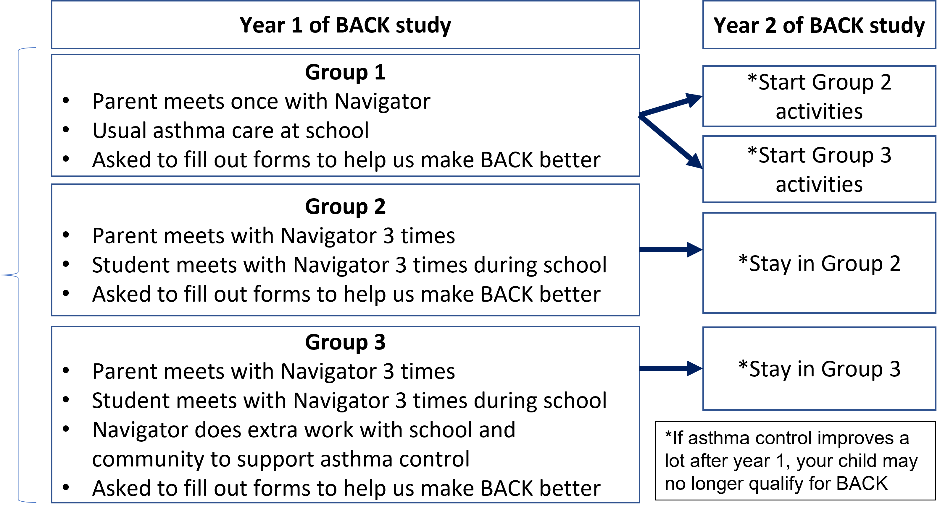
What will I have to do?
If you decide to participate, you and your child will be assigned to one of three groups based on which school your child attends.
All participating families at your child’s school will be in the same group.
Schools in group 1 will go to Group 2 or Group 3 after year 1 of the study.
If you participate in the BACK program, you and your child will:
- Complete visits (phone, in-person, virtual) with an Asthma Navigator from your community
- At these visits, you will learn more about asthma, how to control it, and discuss your needs
- You will be contacted to complete forms to help us know how to make the BACK program better
No matter what group you are in, your child with asthma will get their usual care from their school nurse and clinic health care provider. The BACK program works together with your school nurse and provider. The BACK program does not replace the care that your child gets from their school nurse and provider.
Do I have to participate?
You don’t have to participate in the BACK program if you don’t want to. If you participate, you can choose to stop at any time. Your school nurse and health care provider will continue to provide care to your child. It doesn’t matter to them if you do or do not participate.
How long will I be involved in the program?
Participation in this program could last up to 4 years, but you can choose to end your participation at any time. The activities that you do each year could change depending on your child’s asthma control.
Will I be paid for being in the study?
You will receive a $20 gift card to Amazon or Walmart for 1) each visit with the Asthma Navigator 2) completing a yearly call from a study team member about your child’s asthma control, and 3) completing an end-of-year satisfaction survey. You can receive up to $100 in gift cards each year. In addition, you and your child will get an Asthma Tool Kit valued at $50. Taking part in this study is free.
What are the risks of being in the program?
We don’t think participation will pose any risks for you or your child. Asthma Navigators and study team members will ask questions related to your child’s asthma, health care, and social needs. This might make you or your child feel uncomfortable, weird, or awkward. There will be NO physical exams, painful procedures, or medications given as part of this program.
What about privacy and confidentiality?
Keeping your school nurse and health care providers informed on how your child is doing is an important part of asthma management. If you participate, asthma information will be shared with your child’s school nurse and health care providers at the clinic. We will do our best to keep your personal data confidential and private, but we cannot ensure complete confidentiality.
What if I still have questions?
If you have questions about the program or don’t understand something, please let us know. We are happy to help!
- Do you have general questions about BACK? - contact BACK@cuanschutz.edu
- Do you have questions or concerns about the study? - contact Dr. Stanley Szefler at 720-777-0985
- Do you have questions about your rights as a participant in this program? - contact the Institutional Research Review Board (COMIRB) at 303-724-1055

